**8502 Graphics Coursework**

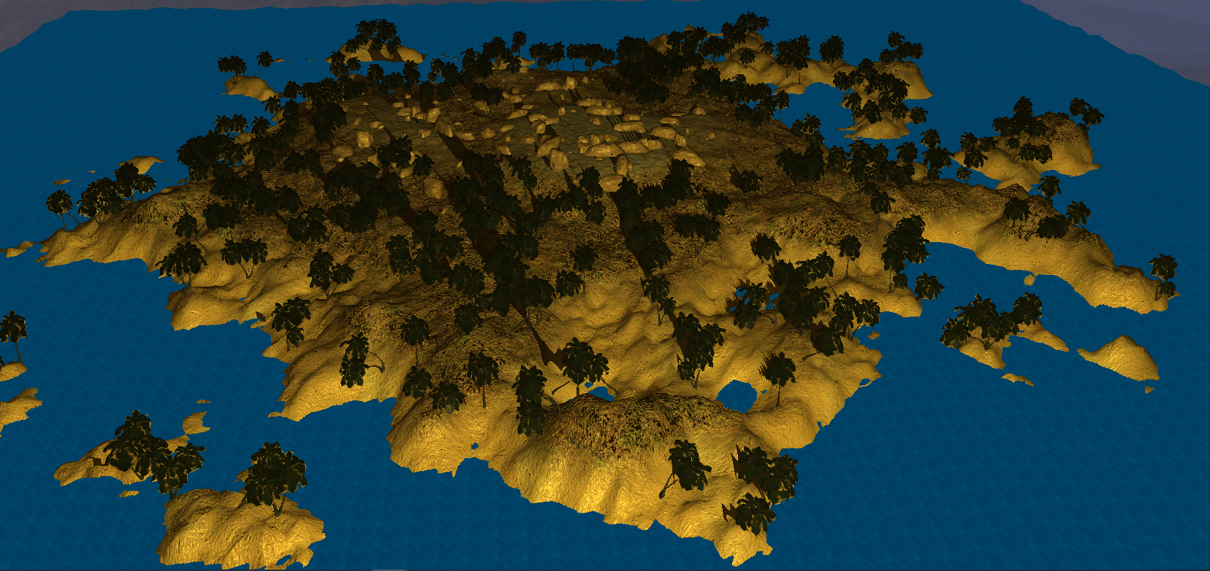

Graphical scene with multiple blended textures based on height with bumpmaps.

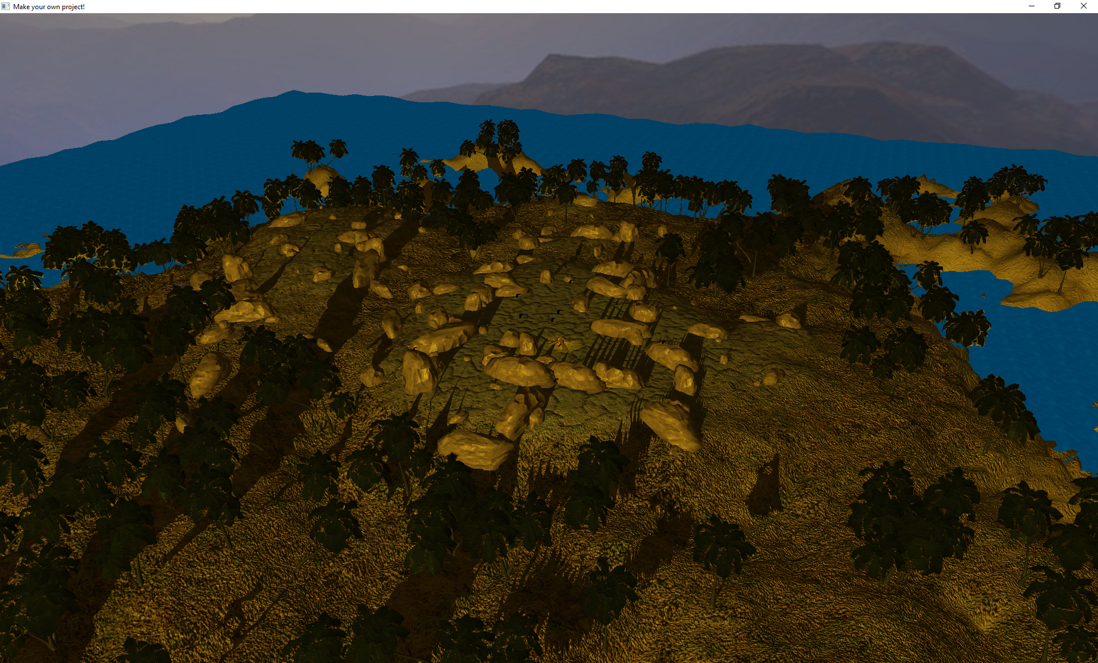

Multiple scene nodes of meshes with individual textures all within a scene hierarchy

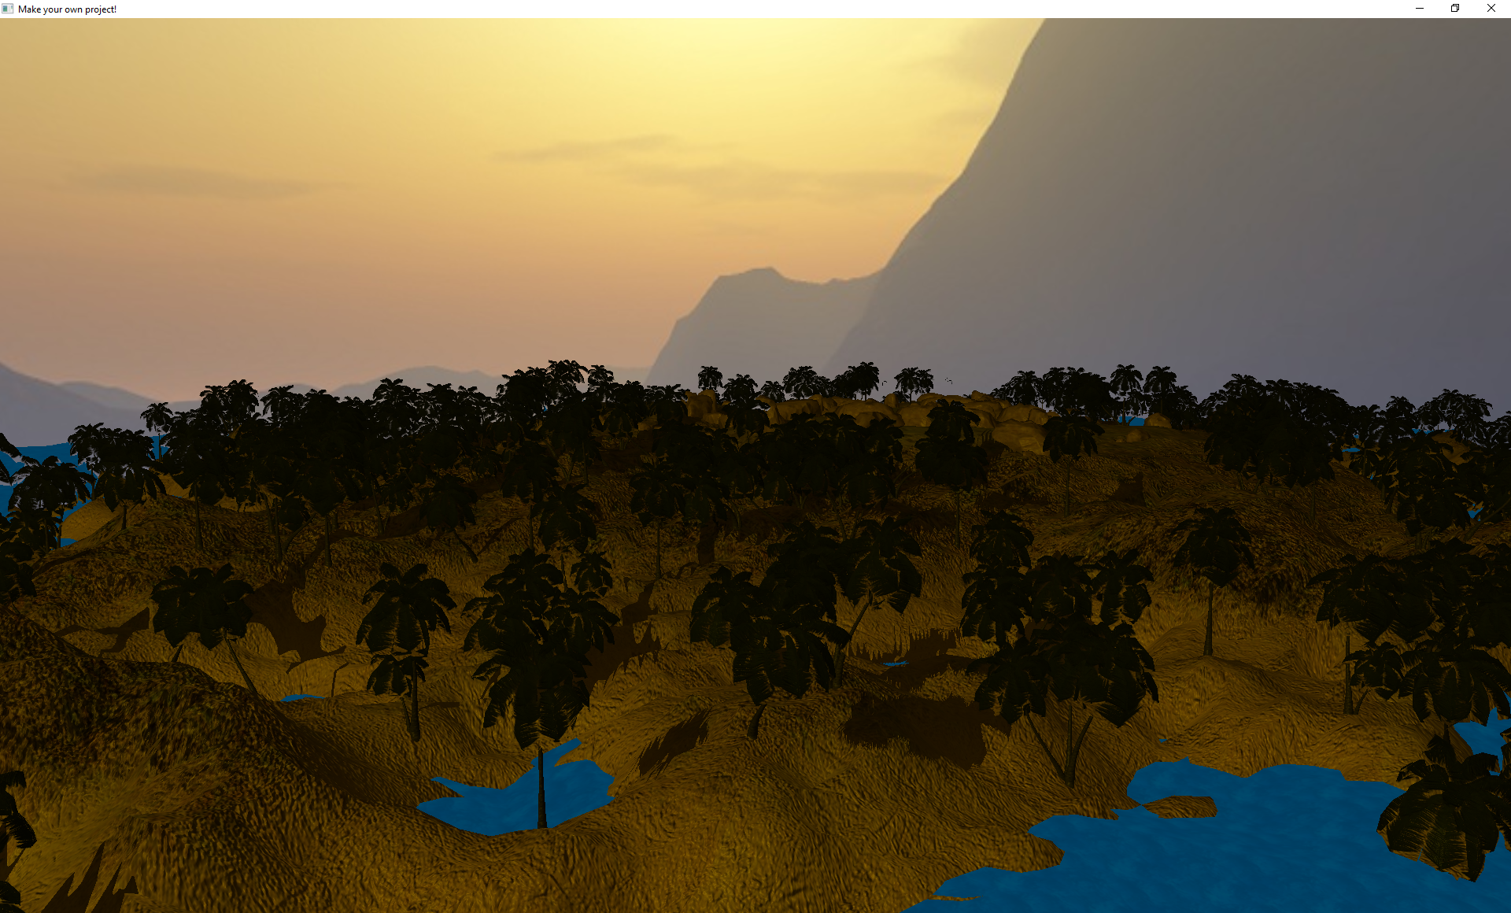

Skybox and daynight cycle including shadow mapping on the scenenodes

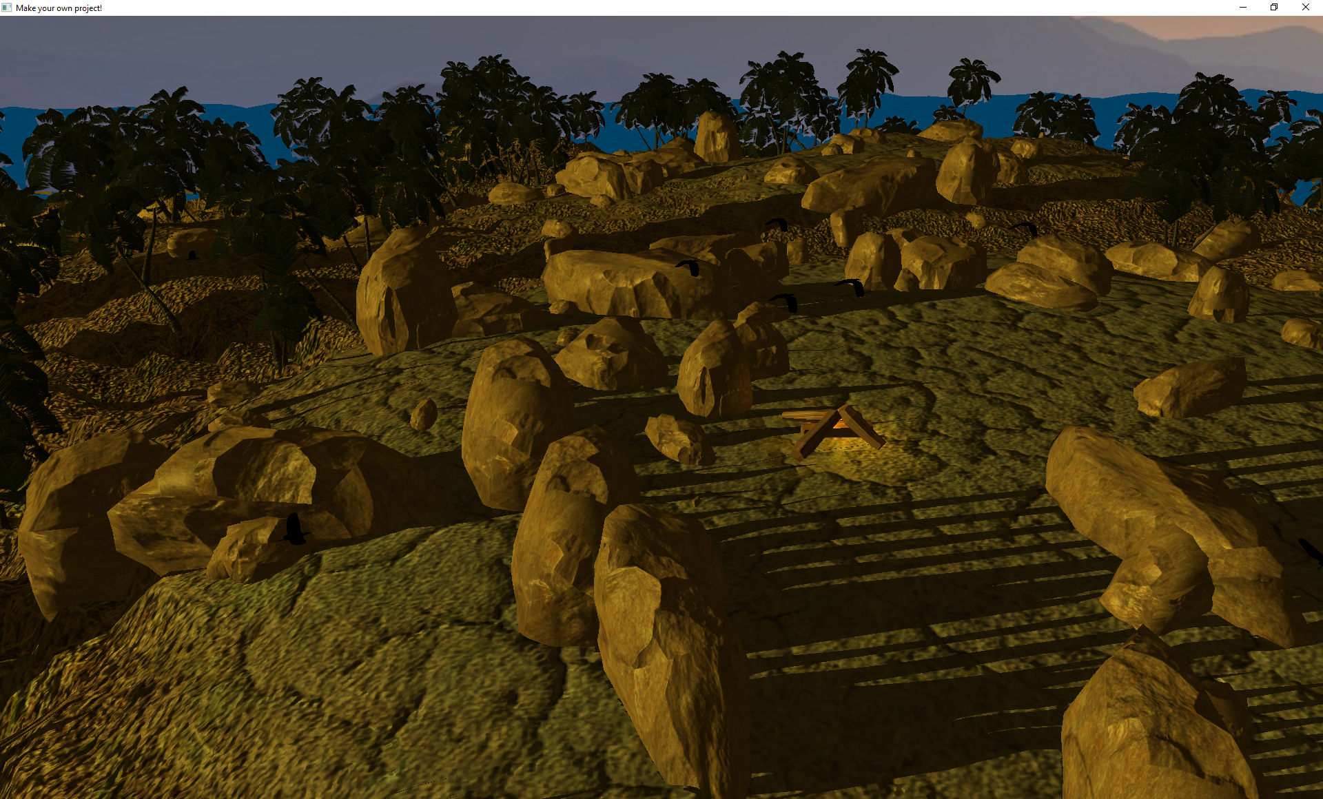

Campfire in the centre of the island with animated birds as its child nodes rotating around it.

Keybinds:

T – toggle freecam

WASD movement controls

Q – increase cam speed

E – decrease cam speed

SPACE – move cam down

SHIFT – move cam up

Link to youtube video: https://youtu.be/vK7ulHFs8BA